NAME: C.RAMA KRISHNA

REG.NO.: 192011478

Program 32:

TM for string coparision:

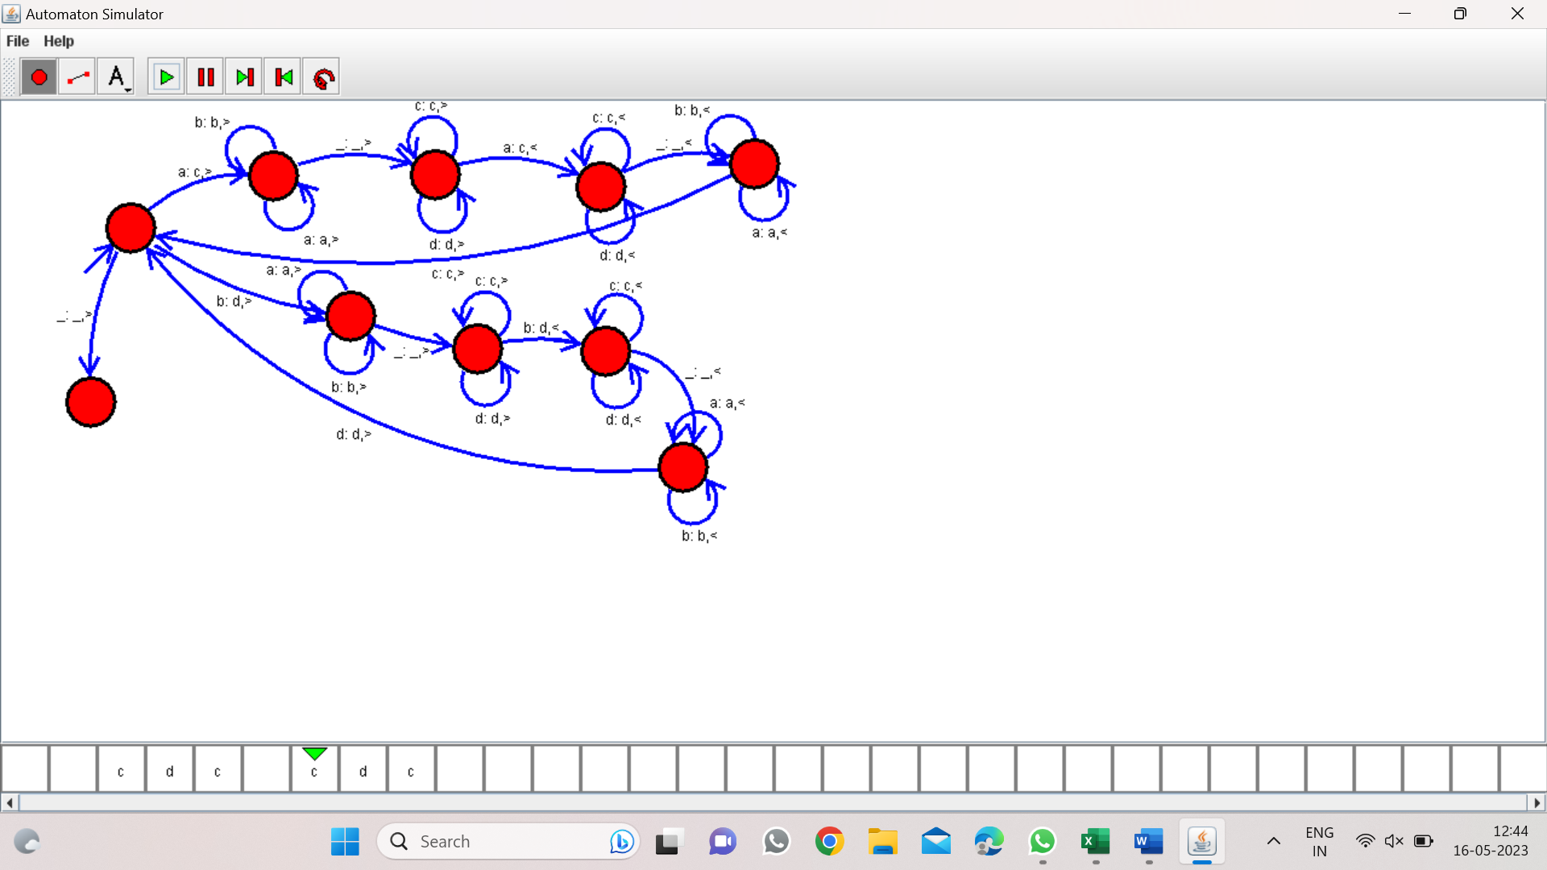

Program 33:

DFA to accept string having abc substring

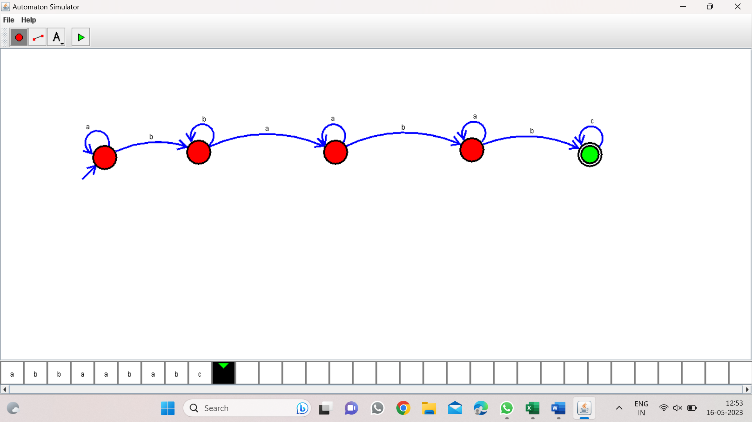

PROGRAM 34:

DFA TO ACCEPT EVEN NUMBER OF C’s:

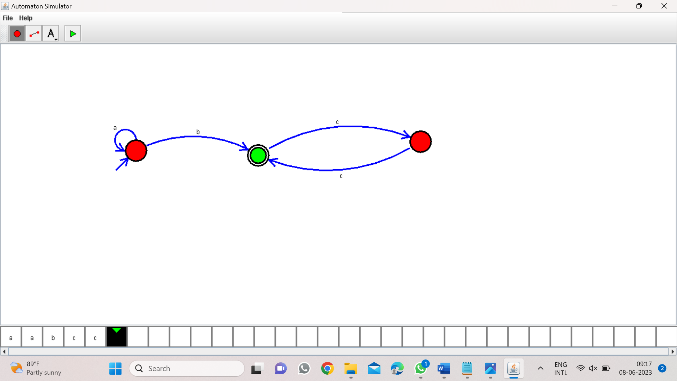

Program 35:

DFA to accept a’s tripled over {a,b}

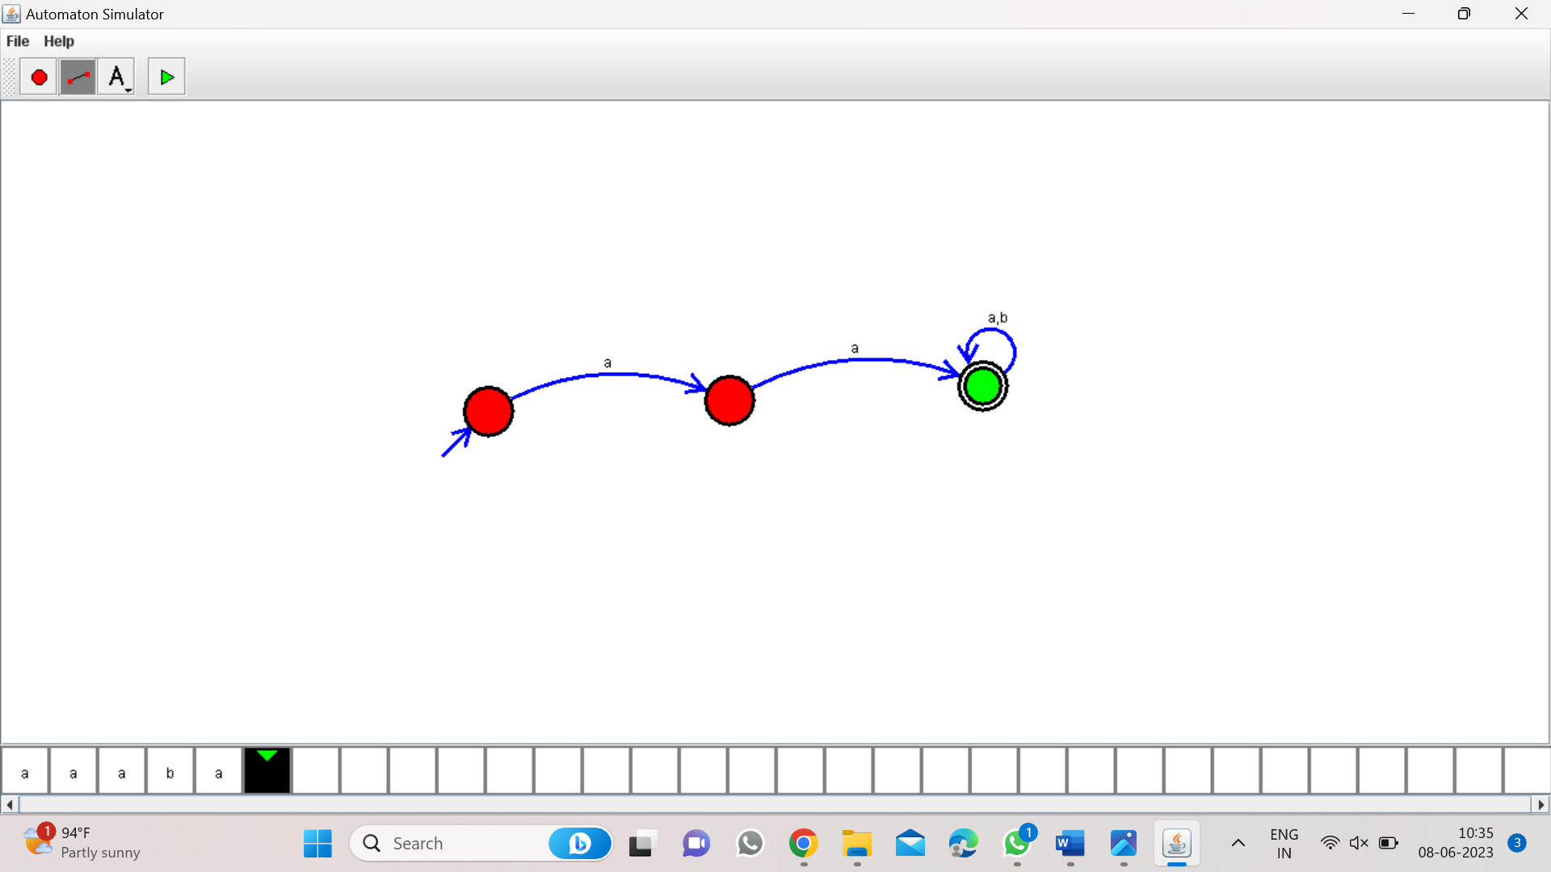

Program 36:

NFA to accept start with a and end with b:

W=abaab

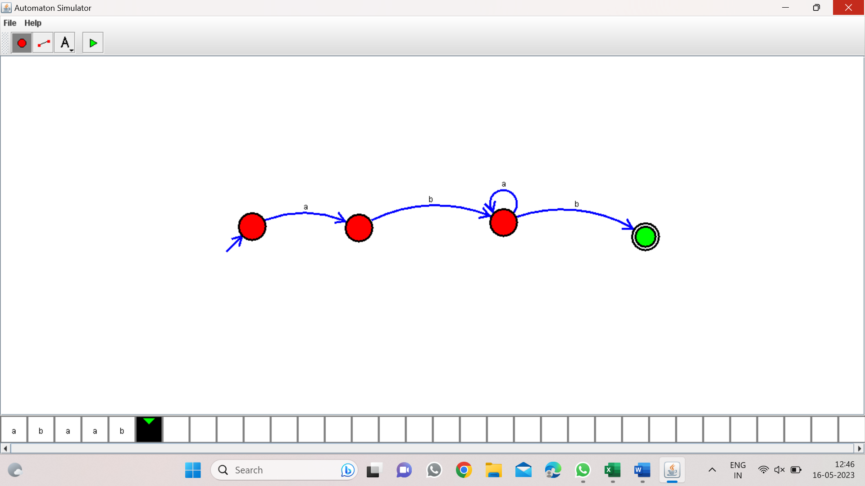

Program 37:

NFA to accept string that start and end with different symbols:

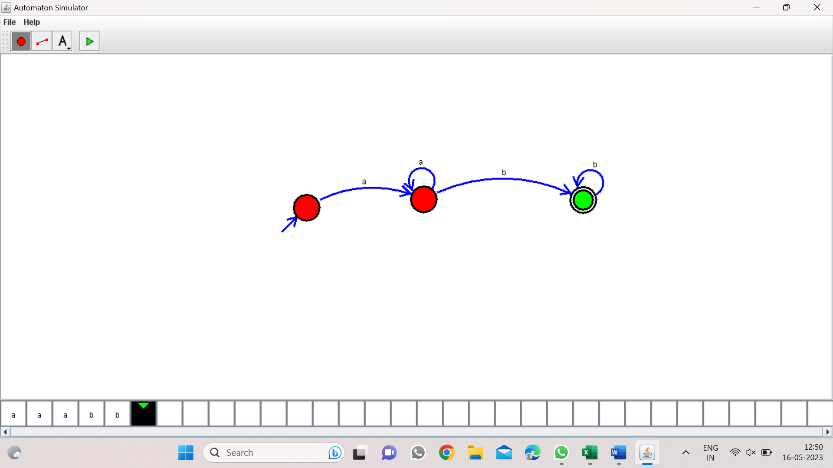

Program 38:

NFA to accept the string bbc,c,bcaaa:

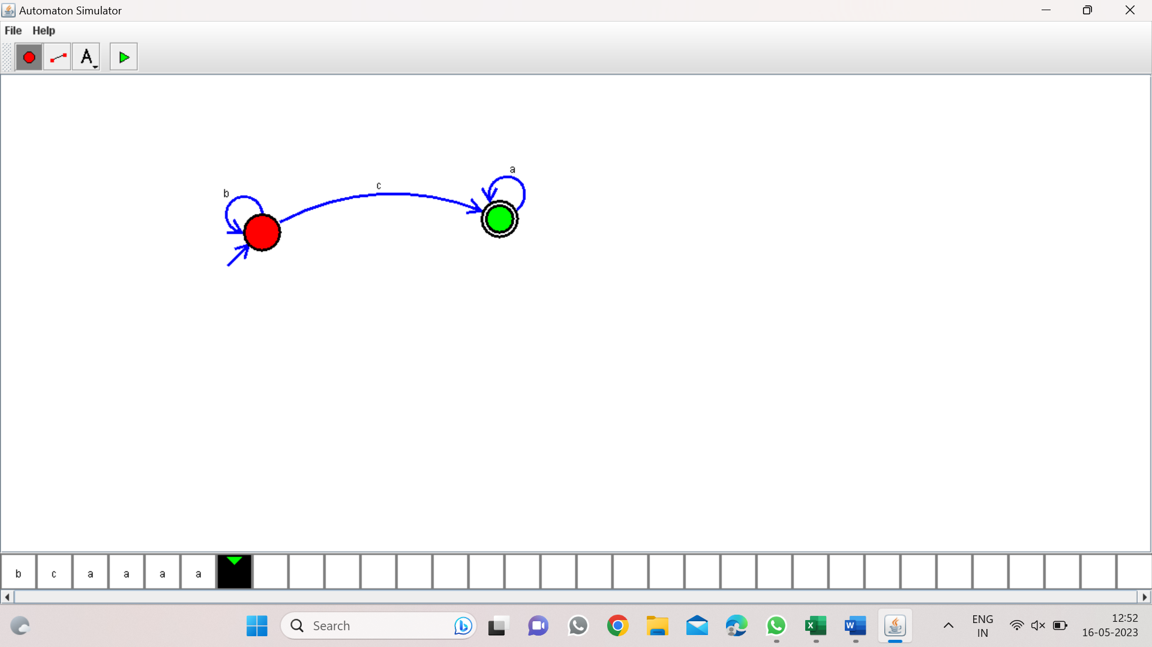

Program 39:

DFA to accept the string that end with abc:

W=abbaababc



Program 40:

NFA to accept any number of b’s:

